Joel Atkinson
April 4, 2026
CSD440 Server-Side Scripting
Assignment 3.2

JoelTable3.php Code:
<!-- Joel Atkinson, April 4, 2026. CSD440 Server-Side Scripting Assignment 3.2
The purpose of this program is to build on the Module 2 PHP table. It uses an external PHP file (Mod_3_Functions.php)
containing a function that accepts two random numbers as parameters and returns their sum. That sum is displayed in
each cell of the HTML table, generated using a PHP nested loop structure.
-->
<!DOCTYPE html>
<html lang="en">
<head>
<meta charset="UTF-8">
<meta name="viewport" content="width=device-width, initial-scale=1.0">
<title>Joel's PHP Random Number Table</title>
<style>
body {
font-family: Arial, sans-serif;
margin: 0;
}
.banner {
background-color: #663399;
padding: 20px 40px;
}
h1 {
color: #DAA520;
margin: 0;
text-align: center;
}
.divider {
border: none;
border-top: 3px solid #DAA520;
margin: 0;
}
.content {
margin: 40px;
display: flex;
justify-content: center;
}
table {
border-collapse: collapse;
}
th, td {
border: 1px solid #666;
padding: 10px 20px;
text-align: center;
}
th {
background-color: #663399;
color: #DAA520;
}
tr:nth-child(even) {
background-color: #f2f2f2;
}
.info {
text-align: center;
color: black;
margin: 20px 40px 40px;
line-height: 1.8;
}
</style>
</head>
<body>
<?php
// Including the external file containing the getCellValue() function
require_once 'Mod_3_Functions.php';
?>
<div class="banner">
<h1>PHP Random Number Table</h1>
</div>
<hr class="divider">
<div class="content">
<table>
<tr>
<th>Col 1</th>
<th>Col 2</th>
<th>Col 3</th>
<th>Col 4</th>
<th>Col 5</th>
</tr>
<!-- Outer loop iterates over each row -->
<?php for ($row = 0; $row < 5; $row++): ?>
<tr>
<!-- Inner loop iterates over each column in the current row -->
<?php for ($col = 0; $col < 5; $col++): ?>
<td><?php echo getCellValue(rand(1, 100), rand(1, 100)); ?></td>
<?php endfor; ?>
</tr>
<?php endfor; ?>
</table>
</div>
<p class="info">
<strong>Author:</strong> Joel Atkinson<br>
<strong>Course:</strong> CSD 440 - Server-Side Scripting<br>
<strong>Assignment:</strong> 3.2<br>
<strong>Description:</strong> This program builds on the Module 2 table by introducing an external PHP function.
The getCellValue() function, stored in Mod_3_Functions.php, accepts two random numbers as parameters and returns
their sum. A PHP nested loop populates each cell with the result, while all table structure remains in standard HTML.
</p>
</body>
</html>

Mod_3_Functions.php Code:
<?php
/* Joel Atkinson, April 4, 2026. CSD440 Server Side Scripting Assignment 3.2 Separate Function php file
The purpose of this portion of the assignment is to create an external file that contains the getCellValue()
function used by JoelTable3.php. The function accepts two random integers as parameters and returns their sum to be
displayed in each table cell. This builds upon our Module 2 assignment which just populated two random numbers using the
rand() function and instead uses require_once to integrate this separately stored function to add the two randomly
generated numbers together and output the sum in each table cell.
*/
/**
* getCellValue()
* Accepts two random integers and returns their sum.
*
* @param int $num1 - First random number
* @param int $num2 - Second random number
* @return int - The sum of the two parameters
*/
function getCellValue($num1, $num2) {
return $num1 + $num2;
}
?>

Screenshot of output when navigating to localhost/JoelTable3.php displaying the table with the sum of the two randomly generated numbers added together by the function in the external file Mod_3_Functions.php using require_once:
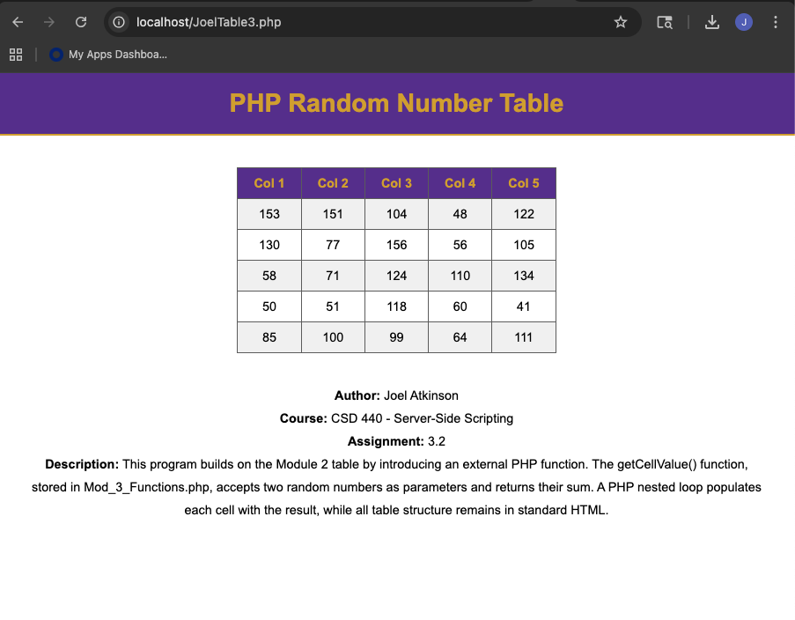
Screenshot of Output again after refreshing the page, proving that the system is functioning correctly and displaying new sums in the cells:
